**National Textile University**

**Department of Computer Science**

Subject: Operating System

Submitted to: Nasir Mahmood

Submitted by: Eemaan Fatima

Reg number:23-NTU-CS-1146

Assignment No.3

Semester:5th

Lab manual 03

**Task 1:**

* In this task firstly i make a new folder in ubuntu and create a file .
* Then i write a simple c code
* For compiling i write this command gcc lab3_task.c -o task 1 (out put file)
* After that for running file i write the comand ./task1.
* This will show the output.

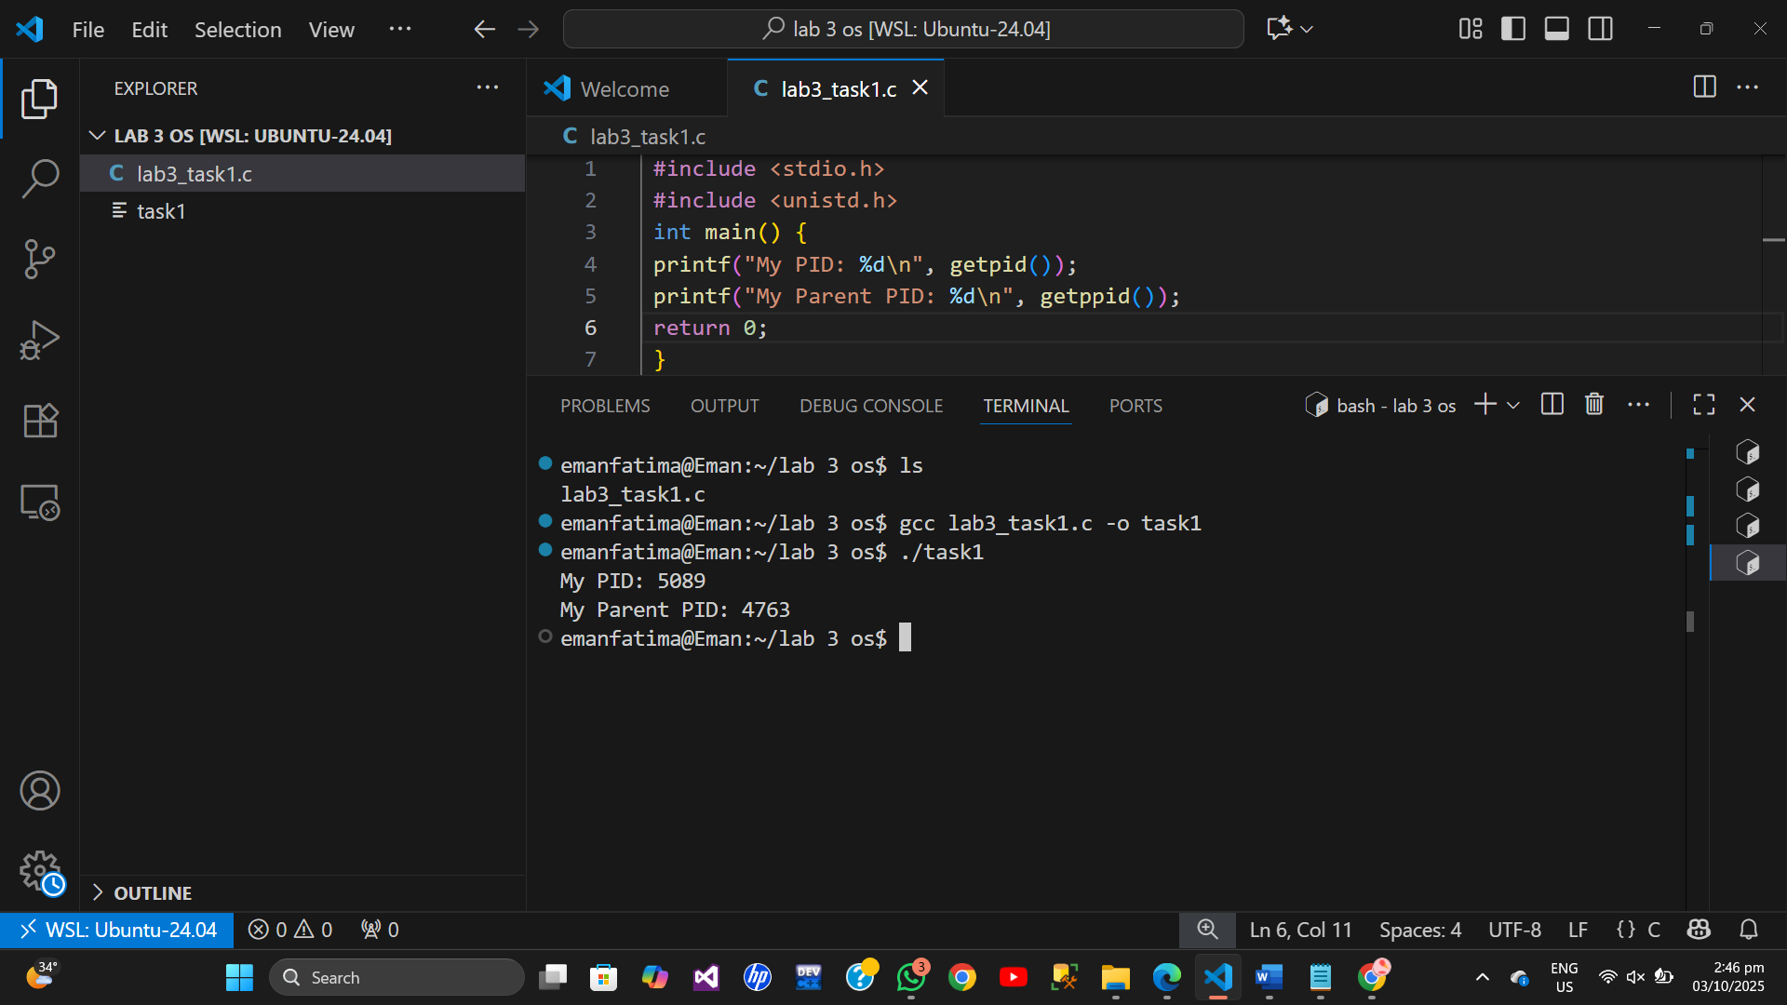

**Task 2:**

Create new proccess by using fork **.**

In this task simply write a code of c then use if ,else if and else for

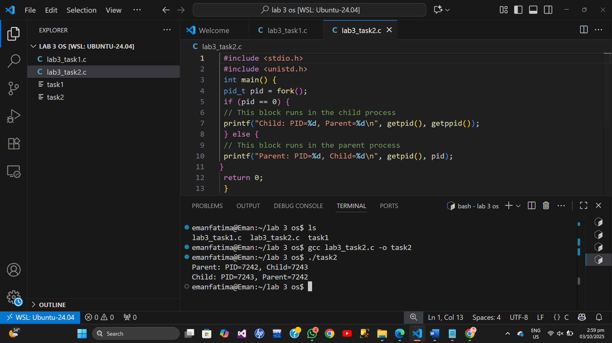

**Task 3:**

**Without wait proccess**

This is orphane proccess becuase parent not wait for child to run.

Execute with ls comand.

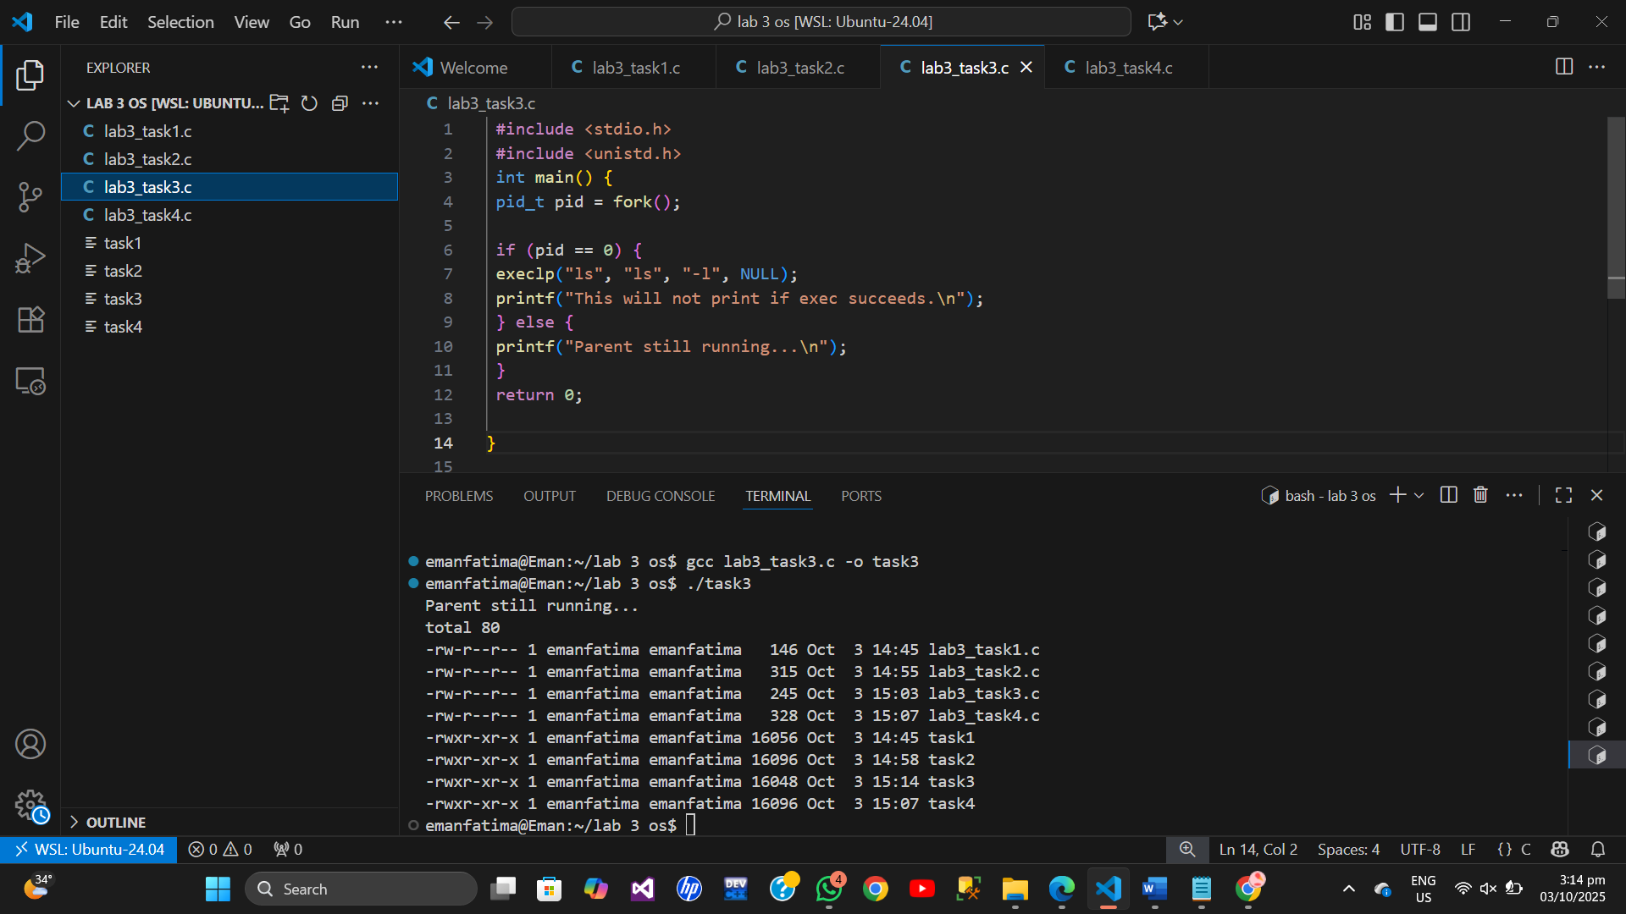

**Task 4:**

**Wait and without wait**

In wait process the child will run frist completely then parent will run after wait .

In without case their is no preference of proccess running parent will run then child will run .

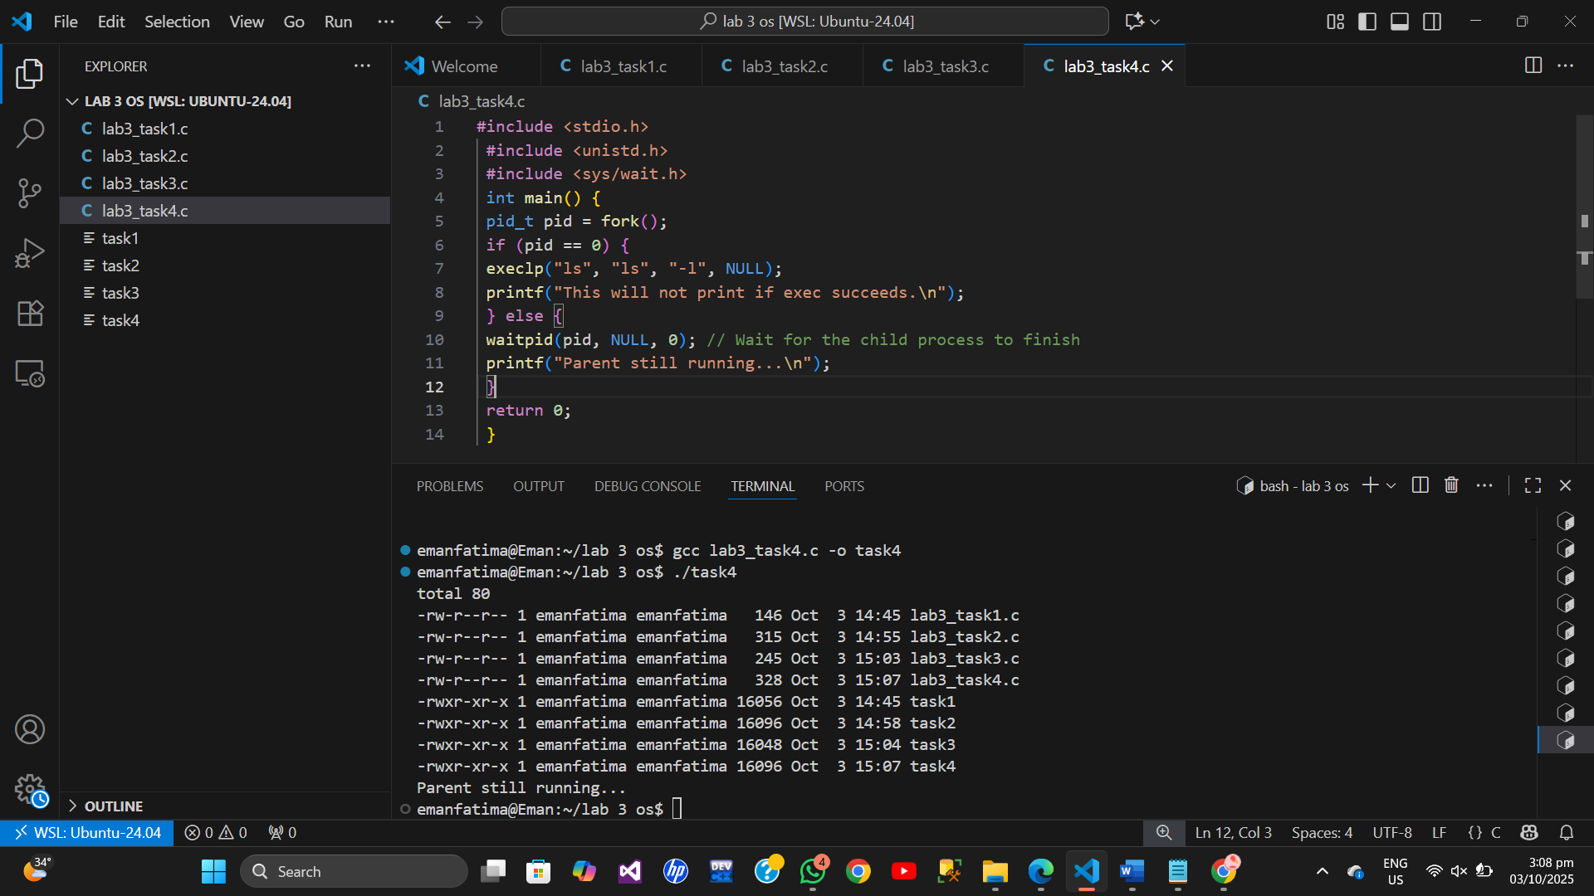

**Task 5:**

Ps : show us proccess which are running.

Pid : proccess id

Time : show time of cpu for runnning proccess

Runnung procces show

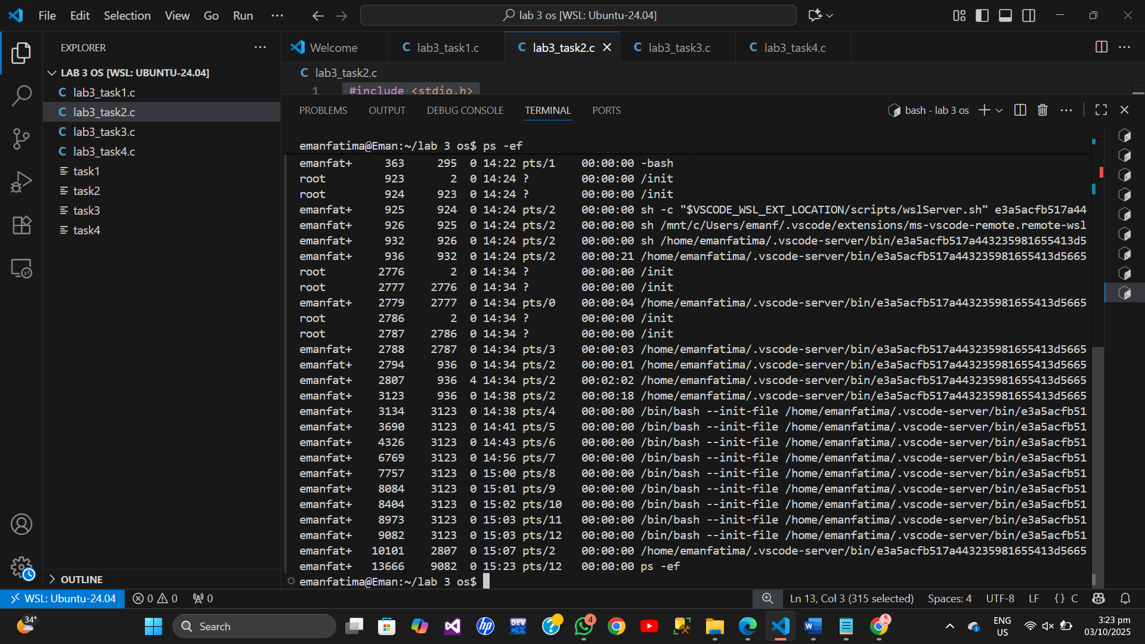

This comand show Dynamic proccess running.

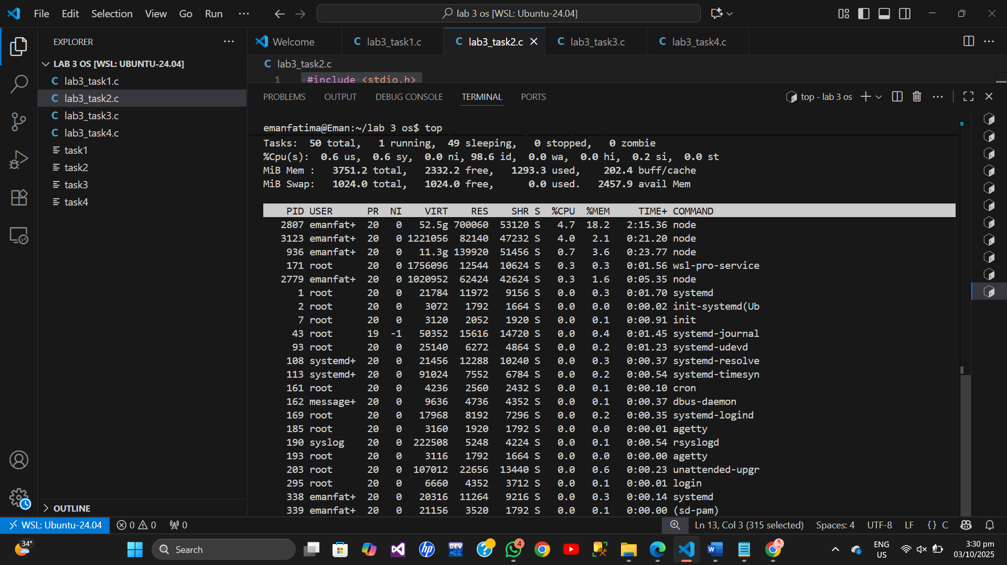

Sleep the terminal for required time

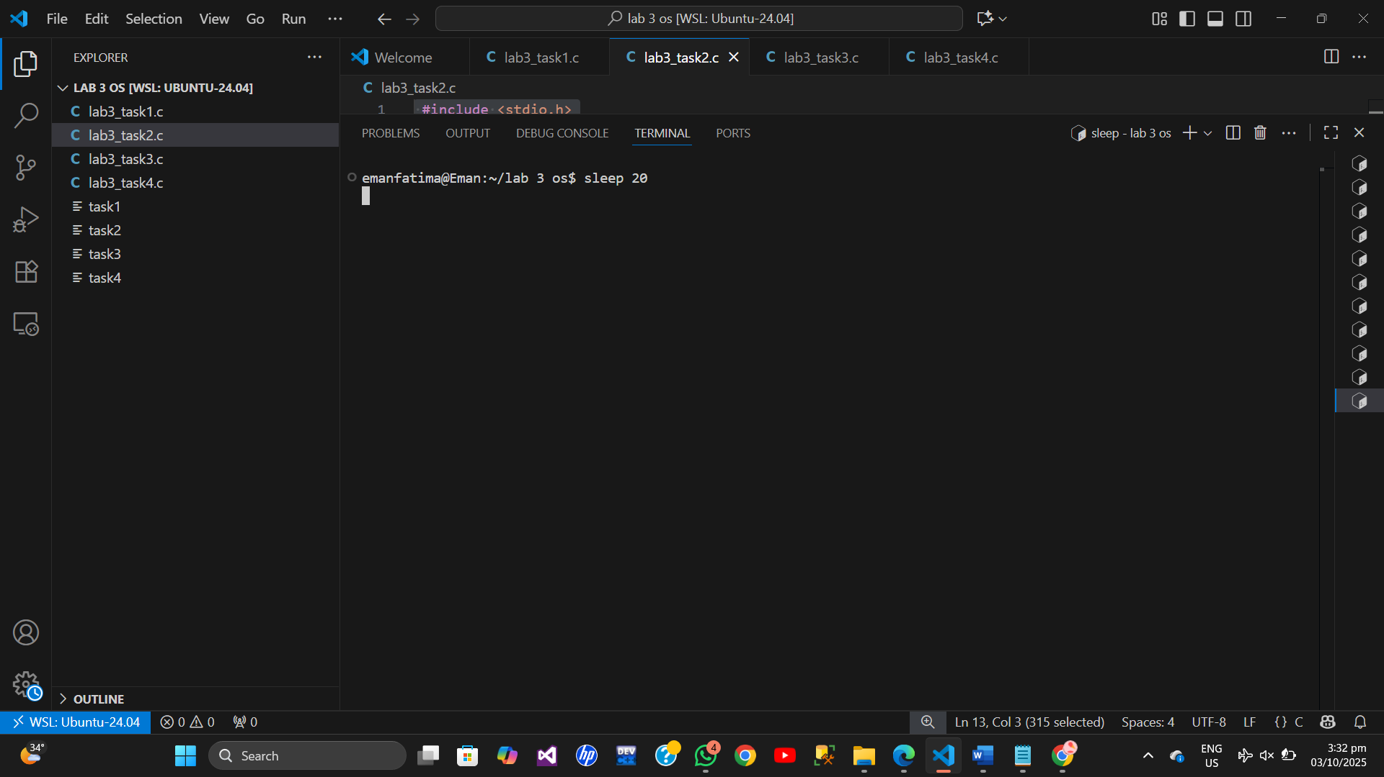

Ruuning in backgroung the procces .

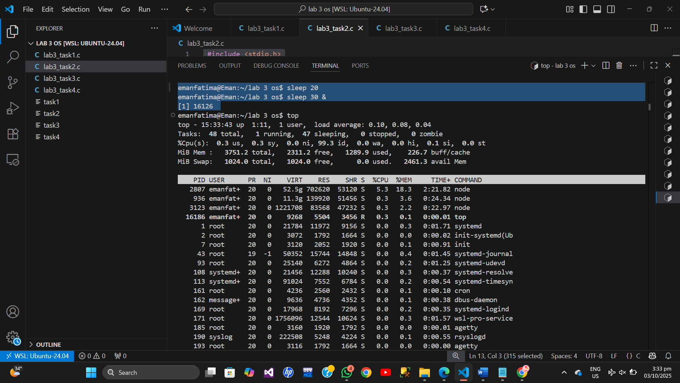

Show id of procces

Infinity loop of procces running

Running in background

Kill the comand runnung in background by using kill and pid number.

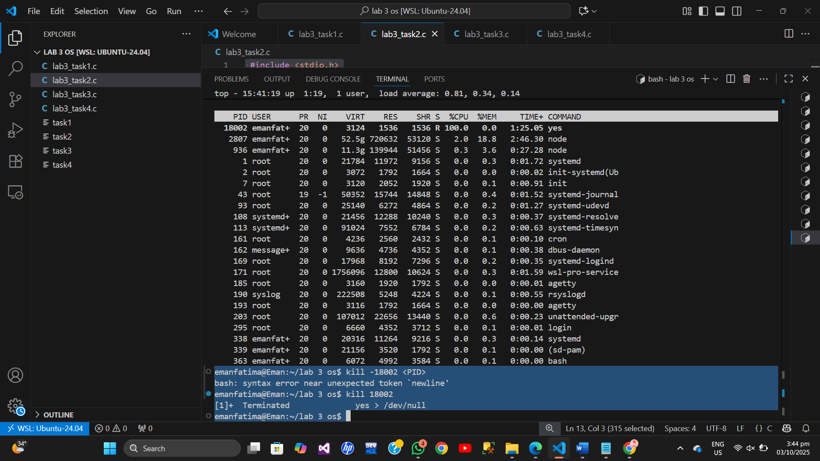

Ps -ef is for giving output of the input text provided in grep

By using | pipe comand

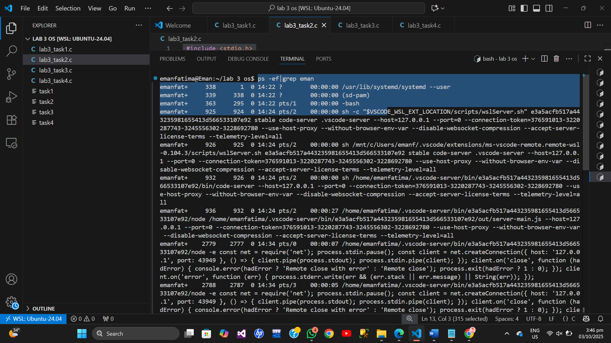

It shows us the jobs means process running in background .

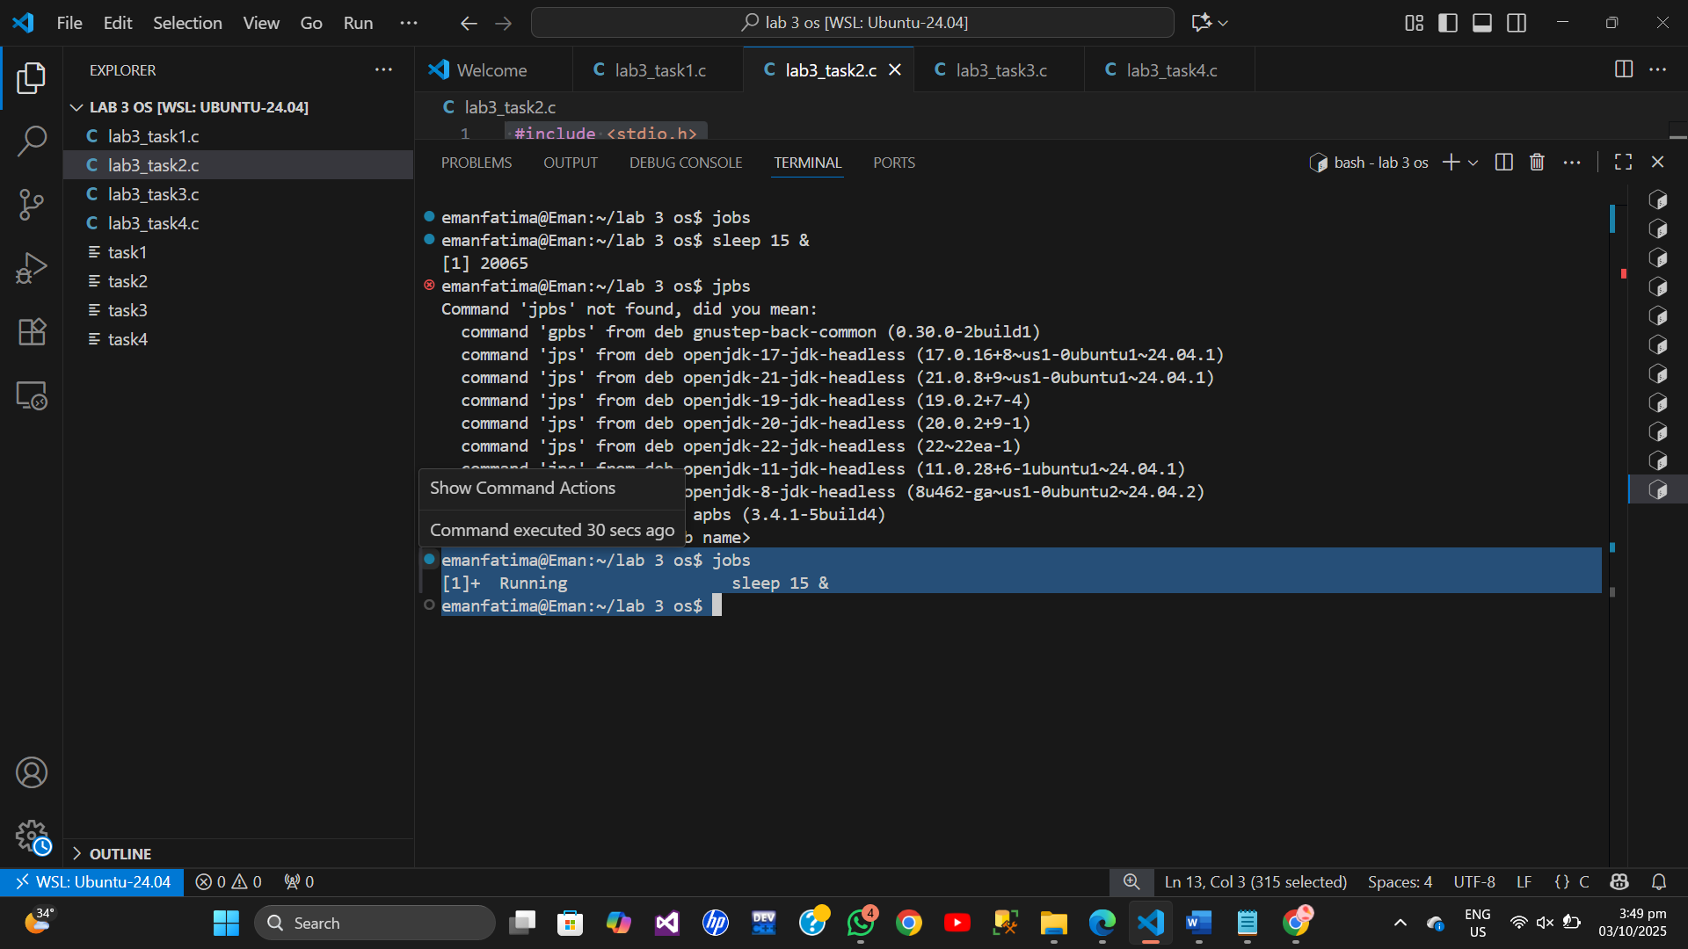

Killall sleep : kill the all sleep jobs running **.**

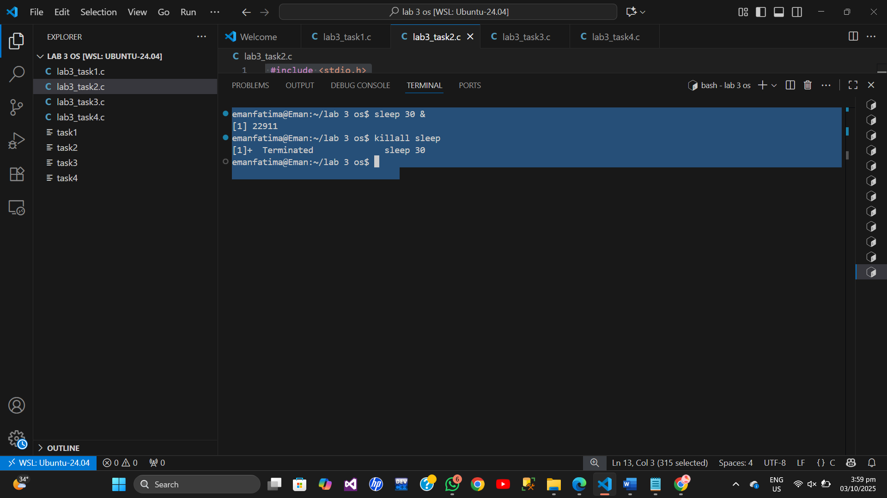

Fg 1 for forground the 1st job .

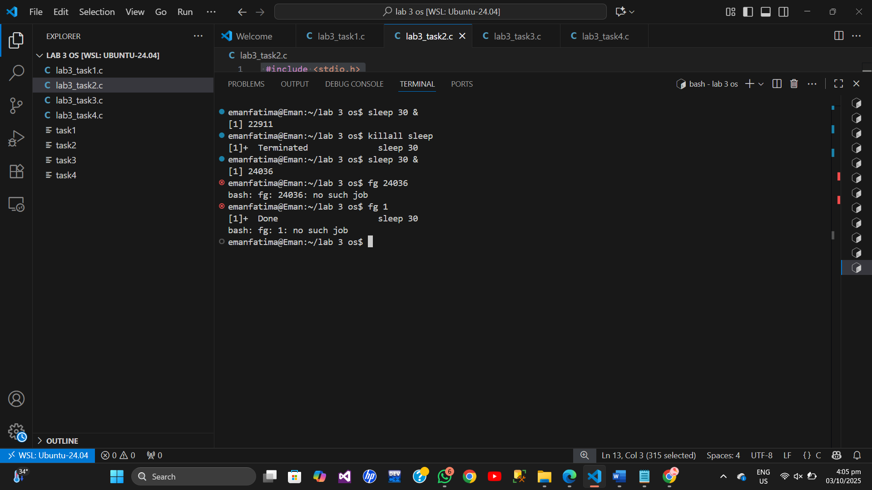

Bg 1 command : resume teh job which is

